NOISE POLLUTION MONITORING
FINAL DOCUMENT

Project Definition:
The project involves deploying IoT sensors to measure noise pollution in public areas and providing real-time noise level data accessible to the public through a platform or mobile app. The primary objective is to raise awareness about noise pollution and enable informed decision-making. This project includes defining objectives, designing the IoT sensor system, developing the noise pollution information platform, and integrating them using IoT technology and Python.
Design Thinking:
1.Project Objectives:
Define objectives such as real-time noise pollution monitoring, public awareness, noise regulation compliance, and improved quality of life.Certainly! Here are definitions for each of the objectives you mentioned:
Real-Time Noise Pollution Monitoring:
Definition:
Real-time noise pollution monitoring refers to the continuous and instantaneous measurement and analysis of noise levels in a given area or environment. It involves the use of sensors and technology to provide up-to-the-minute data on noise pollution, including information on noise sources, intensity, frequency, and duration.
Public Awareness:
Definition:
Public awareness, in the context of noise pollution, is the degree to which the general population is informed and educated about the sources, effects, and consequences of noise pollution. It involves efforts to disseminate information, raise consciousness, and promote understanding among the public about the importance of noise control and its impact on health and well-being.
Noise Regulation Compliance:
Definition:
Noise regulation compliance refers to the adherence to established laws, regulations, and standards that govern acceptable noise levels and practices in a specific region or jurisdiction. It involves individuals, businesses, and organizations following noise-related rules and taking measures to minimize or mitigate their noise emissions to avoid legal violations.

Improved Quality of Life:
Definition:
Improved quality of life, in the context of noise pollution, signifies an enhanced overall well-being and living conditions for individuals and communities due to reduced exposure to disruptive and harmful noise. It encompasses various factors such as better physical and mental health, increased comfort, improved sleep, and a more pleasant living environment, all resulting from effective noise control measures.
2.IoT Sensor Design:
Plan the deployment of IoT noise sensors in various public areas to measure noise levels.Deploying IoT noise sensors in various public areas to measure noise levels requires careful planning and consideration of several factors. Here is a step-by-step plan for the deployment of these sensors:
Define Objectives and Scope:
Clearly define the objectives of the noise monitoring project, including what specific areas you want to cover and the purpose of collecting noise data (e.g., regulatory compliance, public awareness, research).Determine the scope of the deployment, such as the number of sensors needed, the geographical locations, and the frequency of data collection.
Sensor Selection:
Choose appropriate IoT noise sensors based on your project requirements. Consider factors such as sensor accuracy, range, connectivity options (e.g., Wi-Fi, cellular), power source (e.g., battery or wired), and environmental suitability. Ensure that selected sensors are capable of real-time data collection and transmission.
Site Survey:
Conduct a thorough site survey to identify the best locations for sensor placement. Key factors to consider include noise sources, population density, urban planning, and regulatory zones. Ensure that the selected locations are representative of the areas you want to monitor.

Network Infrastructure:
Ensure that there is a reliable network infrastructure (e.g., Wi-Fi or cellular coverage) in place to transmit data from the sensors to a central data repository or server.Evaluate network security measures to protect sensor data.
Data Storage and Management:
Set up a centralized data repository or server to collect, store, and manage data from the IoT noise sensors. Implement data retention policies and backup procedures to ensure data integrity.
3.Noise Pollution Information Platform:
Design a web-based platform and mobile app to display real-time noise level data to the public.Designing a web-based platform and mobile app to display real-time noise level data to the public requires careful planning and consideration of user experience, data visualization, and functionality. Here is a high-level outline of the steps involved in creating such a platform:
Define Project Objectives and Scope:
Clearly outline the goals of the platform, such as providing real-time noise data for public awareness, and establish the scope of the project.
User Research and Personas:
Conduct user research to understand the needs and preferences of your target audience.Create user personas to represent different user types and their specific requirements.
Platform Architecture:
Determine the technical architecture of the platform, including the choice of web and mobile development technologies.Plan for scalability to accommodate growing user numbers and data.
Data Sources and Integration:
Identify the sources of real-time noise data, such as IoT sensors or government monitoring stations. Develop APIs or data connectors to retrieve and integrate this data into the platform.
User Interface (UI) Design:
Create wireframes and mockups for the web platform and mobile app, considering the user personas and user journey.Design an intuitive and user-friendly interface for accessing noise level data.
ESP8266:
Sound level meters are commonly utilized in sound pollution studies for the quantification of various sorts of noise, especially for industrial, environmental, mining, and aircraft noise. The reading from a sound level meter doesn’t correlate well to human-perceived loudness, which is best measured by a loudness meter. Specific loudness may be a compressive nonlinearity and varies at certain levels andcertain frequencies. These metrics also can be calculated in several other ways.Here we are going to make an IoT based decibel meter that will measure the sound in decibels(dB) using a sound sensor and display it to the LCD display along with that, it will also be pushing the readings to the wokwi IoT platform making it accessible from across the world.
Components :
1.Node MCU Board
2.Noise sensor sensor
3.16*2 LCD Module
4 Breadboard
5.Connecting wires
Connectivity :
Bluetooth Low Energy (BLE) :
Bluetooth Low Energy is a wireless personal area network technology designed and marketed by the Bluetooth Special Interest Group aimed at novel applications in the healthcare, fitness, beacons, lsecurity, and home entertainment industries.
Wi-Fi :
Wi-Fi is a wireless networking technology that allows devices such as computers (laptops and desktops),mobile devices (smart phones and wearables), and other equipment (printers and video cameras) to interface with the Internet. It allows these devices—and many more—to exchange information with one another, creating a network.

Working of the Project:
Now that you have understood the code, you can simply upload it to your NodeMCU board and the project should start working. To make sure the values are correct, I compared them to an android application on my phone that could measure sound. As you can see from the pictures, the results were quite close.

Circuit Diagram:

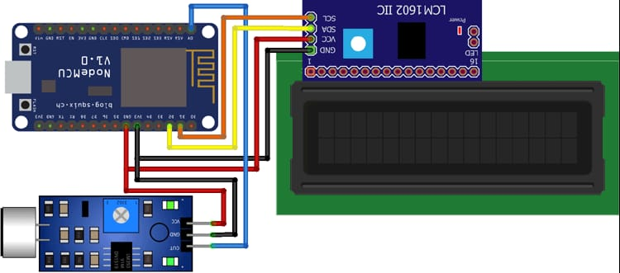

Program:
import machine
import time
import urequests
import ujson
import network
import math
# Define your Wi-Fi credentials
wifi_ssid = 'OPPO_A78(5G)'
wifi_password = 'Bhasith786@noisE' # actual Wi-Fi password
# Connect to Wi-Fi
wifi = network.WLAN(network.STA_IF)
wifi.active(True)
wifi.connect(wifi_ssid, wifi_password)
# Wait for Wi-Fi connection
while not wifi.isconnected():
pass
# Define ultrasonic sensor pins (Trig and Echo pins)
ultrasonic_trig = machine.Pin(15, machine.Pin.OUT)
ultrasonic_echo = machine.Pin(4, machine.Pin.IN)
# Define microphone pin
microphone = machine.ADC(2)
calibration_constant = 2.0
noise_threshold = 60 # Set your desired noise threshold in dB
# Firebase Realtime Database URL and secret
firebase_url = 'https://noise-pollution-bd0ab-default-rtdb.asia-
southeast1.firebasedatabase.app/' # Replace with your Firebase URL
firebase_secret = 'nBsgyQFTqHUe4qExlaZX6VL3mpf5gn6BlpnMiuR0' # Replace with your
Firebase secret
def measure_distance():
# Trigger the ultrasonic sensor
ultrasonic_trig.value(1)
time.sleep_us(10)
ultrasonic_trig.value(0)
# Measure the pulse width of the echo signal
pulse_time = machine.time_pulse_us(ultrasonic_echo, 1, 30000)
# Calculate distance in centimeters
distance_cm = (pulse_time / 2) / 29.1
return distance_cm
def measure_noise_level():
# Read analog value from the microphone
noise_level = microphone.read()
noise_level_db = 20 * math.log10(noise_level / calibration_constant)
return noise_level, noise_level_db
# Function to send data to Firebase
def send_data_to_firebase(distance, noise_level_db):
data = {
"Distance": distance,
"NoiseLevelDB": noise_level_db
}
url = f'{firebase_url}/sensor_data.json?auth={firebase_secret}'
try:
response = urequests.patch(url, json=data) # Use 'patch' instead of
'put'
if response.status_code == 200:
print("Data sent to Firebase")
else:
print(f"Failed to send data to Firebase. Status code:
{response.status_code}")
except Exception as e:
print(f"Error sending data to Firebase: {str(e)}")
try:
while True:
distance = measure_distance()
noise_level, noise_level_db = measure_noise_level()
print("Distance: {} cm, Noise Level: {:.2f} dB".format(distance,
noise_level_db))
if noise_level_db > noise_threshold:
print("Warning: Noise pollution exceeds threshold!")
# Send data to Firebase
send_data_to_firebase(distance, noise_level_db)
time.sleep(1) # Adjust the sleep duration as needed
except KeyboardInterrupt:
print("Monitoring stopped")
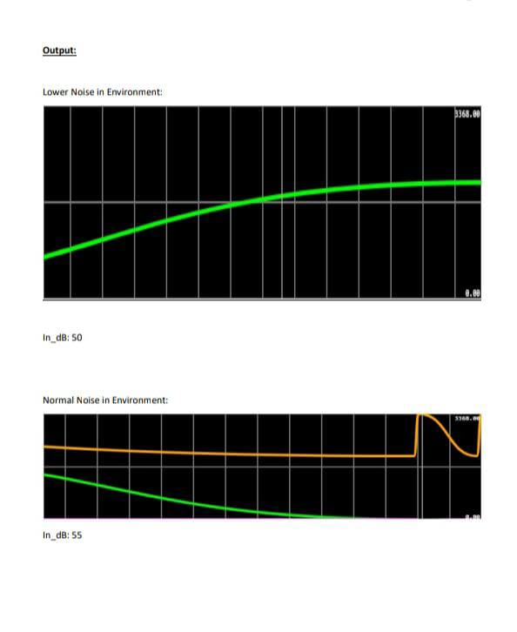

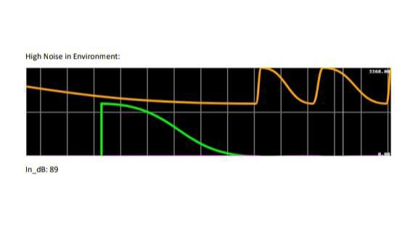

conclusion:
An IoT-based noise pollution monitoring system offers a promising solution to address the growing concern of noise pollution in urban environments. By leveraging sensors, data collection, and real-time analysis, it enables efficient tracking, analysis, and management of noise levels. This system not only provides valuable data for research and policy-making but also empowers communities to take informed actions to mitigate noise pollution, leading to improved quality of life and a healthier environment. As technology advances and data accumulates, the potential for smarter and more effective noise pollution control is on the horizon.

